**HR Attrition Analytics Report 2012-2022**

Company: **Palo Technology Limited**

Presented By: **Open-Eye Consulting**

Date: 3rd July 2025.

**INTRODUCTION**

**Palo Technology** Limited is a fast-growing organization that recognizes the vital role of human capital in achieving strategic business objectives. With three core departments—Technology, Sales, and Human Resources—the company is committed to maintaining workforce stability and performance. To support this goal, Palo Technology engaged a Business Analyst to perform an in-depth HR Attrition Analysis, aimed at uncovering the root causes of employee turnover and identifying opportunities for proactive retention strategies.

This HR Attrition Analysis Report provides a data-driven assessment of employee turnover, using advanced Power BI dashboards and analytics to uncover patterns and risk factors associated with staff attrition. The insights gathered are aimed at guiding executive and HR leadership in implementing effective retention strategies.

To deepen the understanding beyond historical trends, a predictive attrition model was also developed as part of this analysis. This model identifies employees who are at higher risk of leaving the organization based on key indicators such as job satisfaction, tenure, salary, role type, and work-life balance metrics. This forward-looking approach enables proactive intervention rather than reactive replacement, aligning with Palo Technology’s strategic focus on sustainability and efficiency.

The data has been anonymized and segmented by key demographics, including gender, age group, education level, marital status, ethnicity, and job role. Supporting metrics such as job satisfaction, compensation, training access, and work-life balance further enrich the analysis.

**Objectives**

The main objectives of the HR Attrition Analysis are:

1. To identify key factors influencing employee attrition across various job roles, departments, and demographic segments.
2. To quantify the overall attrition rate and assess departmental disparities particularly within Technology and Sales, which account for the majority of attrition cases.
3. To evaluate employee satisfaction metrics, including job satisfaction, work-life balance, and training opportunities, and correlate them with attrition trends.
4. To segment attrition by demographic and professional factors such as age, education level, gender, ethnicity, and marital status.
5. To build a predictive model that estimates the probability of attrition for each employee using machine learning techniques, enabling HR to focus efforts on at-risk employees.
6. To provide visual insights through interactive dashboards that highlight key trends and enable real-time filtering based on selected criteria.
7. **Analysis Findings**

The total number of employees from 2012 to 2022 is 1470, the total Attrition over the span of 10 years is 237, attrition rate 16.12%, Average tenure of exited staff is 2.43 years. The company has spent an average of $82,260.

1. **Attrition Over Time**

Yearly Attrition trend: Analysis present that 15 to 28 employees per year with spikes in 2016 and 2020. The trend shows periodic rises and falls, rather than a steady trend. These fluctuations suggest that employee turnover may not be random or solely due to internal HR factors but can be linked to larger external events such

* Economic downturns possibly leading to layoffs, budget cuts, etc
* Organization changes
* Policy changes / change in the labor market demand

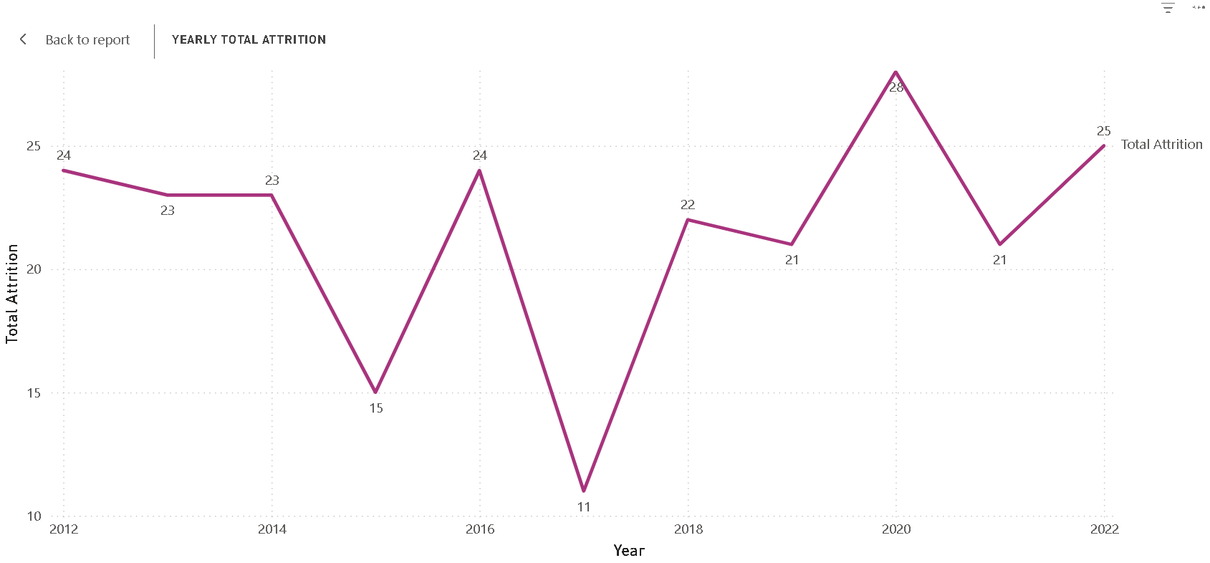

1. **Department- Wise Attrition**

The Technology and Sales department have the highest attrition, indication possible Job pressure or mismatch. Over 56% of attrition comes from the Technology department, Indication a serious retention challenge in this department

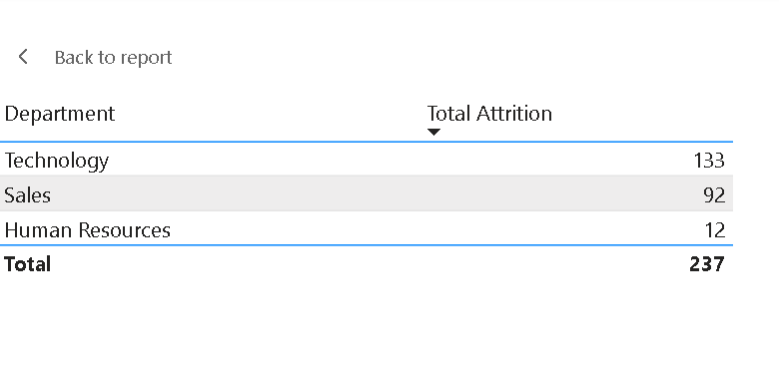

1. **Attrition by Job Role**

The data presents that critical Technical and client-facing roles are experiencing the highest turnover, which may signal issues with Job satisfaction, growth opportunities or workload

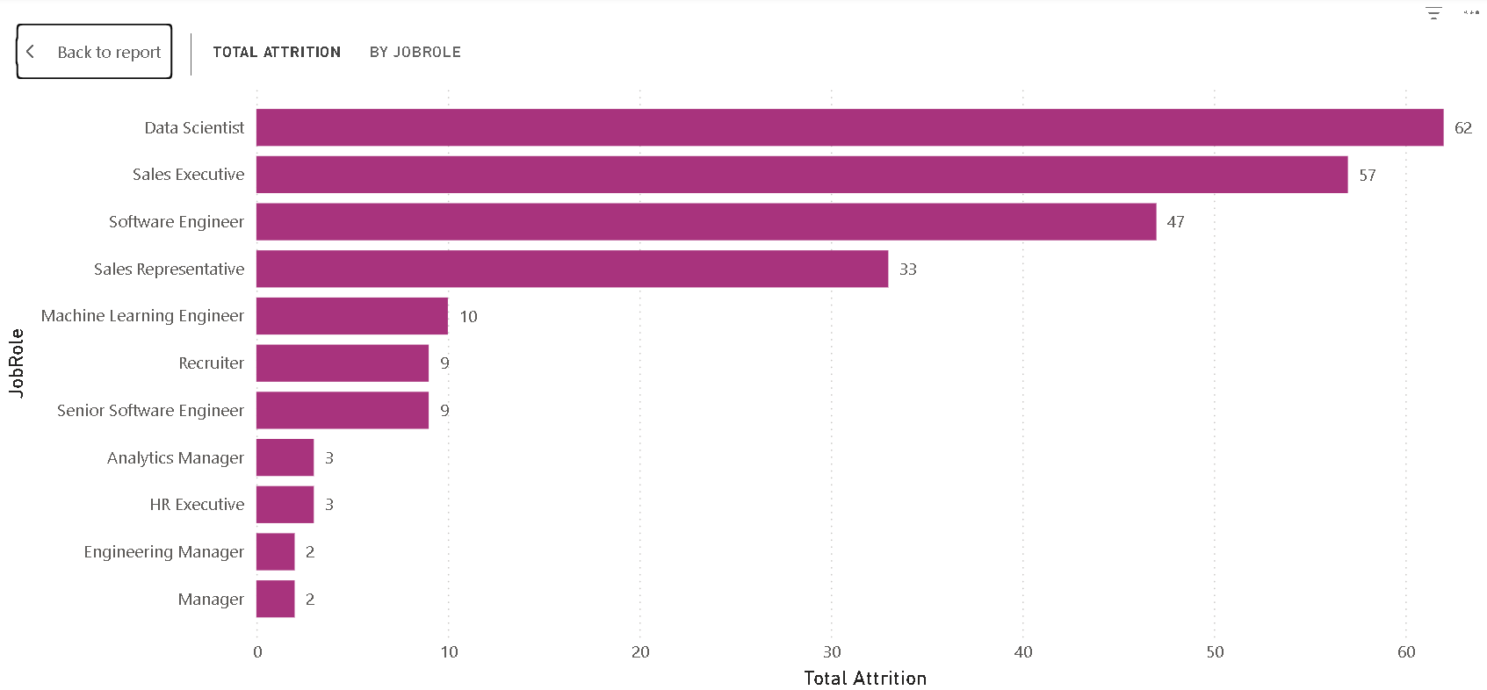

1. **Attrition by Age**

Peak attrition occurs in the 28-30 age group with a spike of **47.83%**

Younger employees (20-30) show significantly higher attrition compared to older age groups.

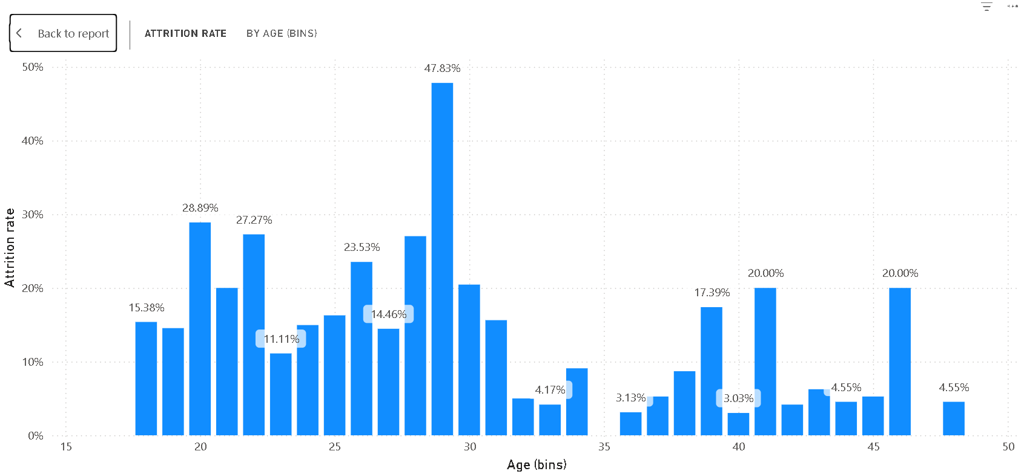

1. **Attrition by Education**

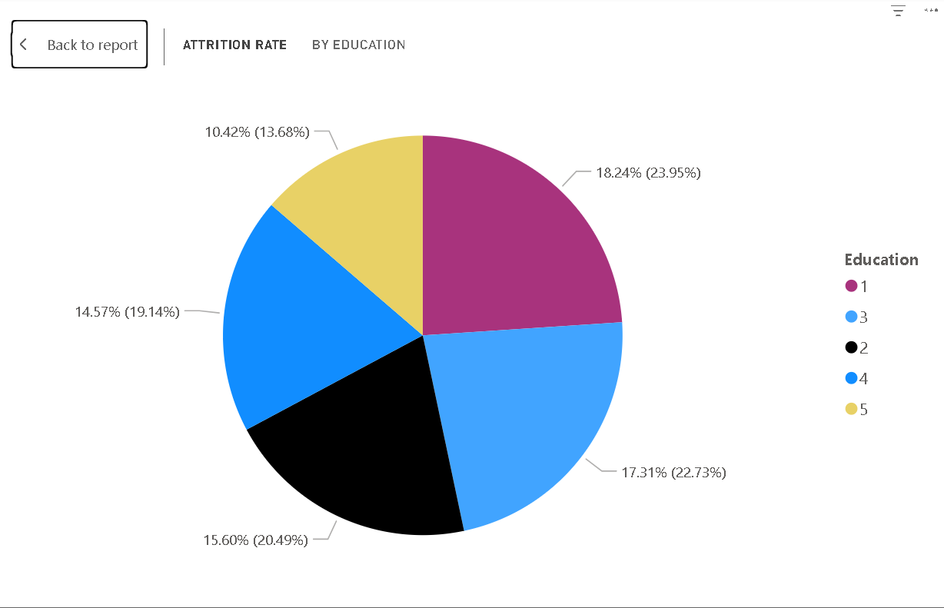

The dataset represented various levels of education with numerical values

1. No formal qualifications
2. High school
3. Bachelors
4. Masters
5. Doctorate

No formal education which is level 1 accounts for the highest attrition rate **23.95%.** it is observed that there is some form even distribution of attrition across education levels, but the least educated groups show slightly higher rate of attrition.

1. **Ethnicity -Based Attrition**

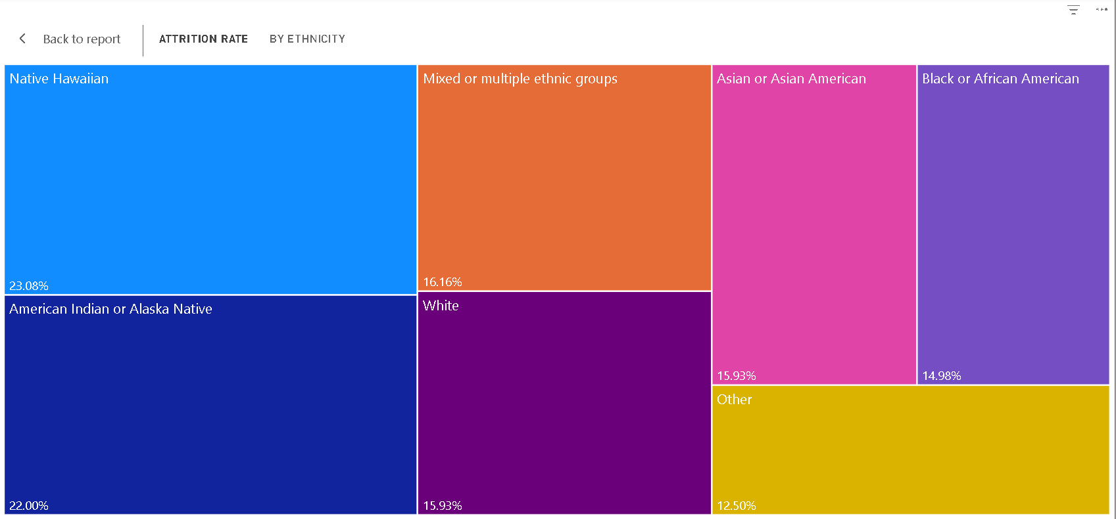

The diagram shows that certain ethnic minority groups have disproportionately high attrition rates, Highlighting a potential issue of inclusion, representation or even engagement.

The highest Attrition Rate by group:

* Native Hawaiian (23.08%)
* American Indian or Alaska Native (22%)

**Insight Analysis with embedded slicers**

This dashboard was designed with the intent to explore potential gender disparities within the organization, considering employees' marital status whether single, married, or divorced. While this report provides a general summary, a more detailed breakdown will be shared during the presentation

**Focus: Gender-Based Attrition Overview**

The analysis reveals the following gender-related insights.

**Female Employees:**

* Total Hired: 675
* Employees who left: 104
* Attrition Rate: 15%
* Average Tenure: 2.6 years
* Average Salary: $73,850

**Male Employees:**

* Total Hired: 651
* Employees who left: 114
* Attrition Rate: 18%
* Average Tenure: 2.28years
* Average Salary: $88,240

**Non-Binary Employees:**

* Total Hired: 124
* Employees who left: 19
* Attrition Rate: 15%
* Average Tenure: 2.37 years
* Average Salary: $92,430

**Gender Not Specified:**

* Total Hired: 20
* No attrition or additional data reported

The data shows that male employees show a higher attrition rate of 18% compared to other gendered employees. Average salaries and tenure vary, with non-binary employees reporting the highest average salary while male employees have the lowest average tenure. These requires deeper investigation into compensation structure, role distribution across gender identities so as to achieve gender equality.

**Female Attrition Trends**

The company experienced a peak in female employee attrition in 2012, with a total of 18 employees leaving. Following this, there was a significant decline, reaching the lowest point in 2017 with only 2 recorded cases. However, attrition gradually increased thereafter, peaking again in 2022 with 13 female employees leaving.

By department, the Technology department saw the highest female attrition with 63 departures, followed by Sales with 35 and Human Resources with 6.

In terms of age, the majority of female employees who left were 29 years old, representing 47.37% of total female attrition.

**Job roles most impacted include**:

* Data Scientist: 31 employees
* Software Engineer: 22 employees
* Sales Executive: 20 employees

**Attrition by education level** reveals that most female employees who left had:

* Level 1 (No formal qualification): 20%
* Level 2: 16.18%
* Level 3 (Bachelor’s Degree): 15.24%

**Attrition by Ethnicity (Female):**

* American Indian or Alaska Native: 30%
* Asian or Asian American: 16.98%
* Black or African American: 16.85%
* White: 14.72%
* Mixed or Multiple Ethnic Groups: 14.14%
* Other: 12.50%
* Native Hawaiian: 8.12%

**Male Attrition Trends**

Attrition among male employees peaked in 2016 (18 departures) and again in 2020 (15 departures). Similar to female employees, high attrition was concentrated in the Technology, Sales, and Human Resources departments, with 62, 46, and 6 departures respectively.

By **Age,** the largest proportion of attrition occurred among:

* 29-year-olds: 43.48%
* 41-year-olds: 30%

There appears to be lower retention among employees under 30.

Regarding **Job roles**, the most affected positions were:

* Data Scientist: 29 employees
* Sales Executive: 28 employees
* Software Engineer: 21 employees

Unlike the trend in female attrition, male employees with higher education levels showed higher attrition rates:

* Level 3 (Bachelor’s Degree): 19.69%
* Level 1 (No formal qualification): 18.46%
* Level 5 (Doctorate): 17.39%

**Attrition by Ethnicity (Male):**

* Native Hawaiian: 44.44%
* Mixed or Multiple Ethnic Groups: 18.52%
* White: 18.23%
* Asian or Asian American: 14.58%
* Black or African American: 14.43%
* American Indian or Alaska Native: 12.50%
* Other: 12.50%

**Non-Binary Attrition Trends**

Attrition among non-binary employees was recorded at 3 employees in each of the years 2014, 2018, and 2020.

**By department:**

* Sales: 11 employees
* Technology: 8 employees

Age-wise, 75% of non-binary employees who left were 29 years old, and 50% were 41 years old.

**Job roles** most affected:

* Sales Executive: 9 employees
* Software Engineer: 4 employees
* Data Scientist: 2 employees
* Sales Representative: 2 employees

**Education levels** among non-binary employees who left the company:

* Level 4 (Master’s Degree): 18.92%
* Level 3 (Bachelor’s Degree): 18.60%
* Level 1 (No formal qualification): 11.76%
* Level 2: 8.70%

**Attrition by Ethnicity (Non-Binary):**

* American Indian or Alaska Native: 40%
* Native Hawaiian: 20%
* Mixed or Multiple Ethnic Groups: 18.75%
* Asian or Asian American: 18.18%
* White: 13.04%
* Black or African American: 11.11%

1. **Findings from Slide 2: Role-Specific Analysis**

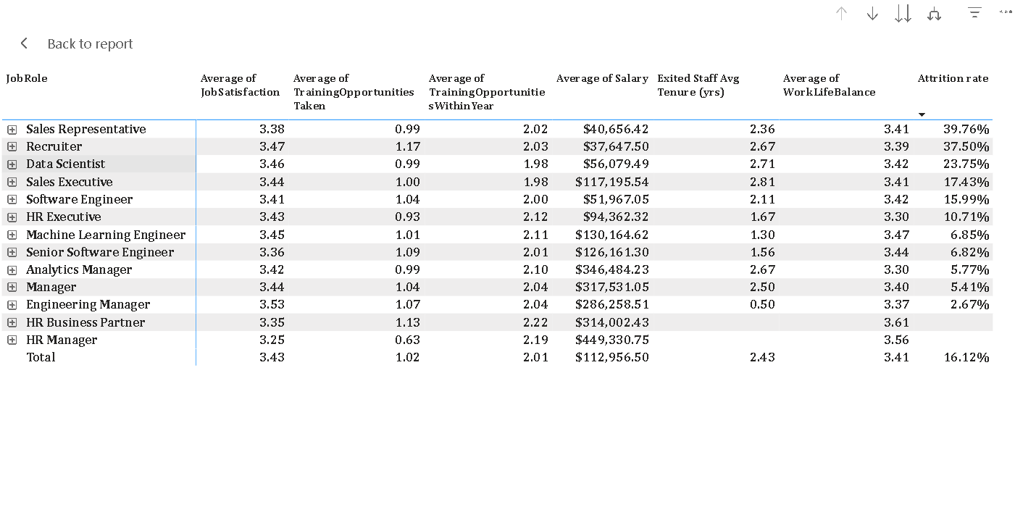To establish a reason for attrition across various job roles various indicators were explored such as:

* Average Job Satisfaction
* Average Training Opportunity taken
* Average Training Opportunities within the year
* Average Existed staff tenure
* Average Work balance
* Attrition rate

The average Job satisfaction is 3.43 out of 5 across roles indicating most of employees are neutral regarding their Job role satisfaction. It was observed that sales representative has the highest attrition rate 39.76% followed by Recruiter 37.50%, and Data scientist 23.75%. These roles have decent Job satisfaction rating; however, they receive the lowest salary on an average as their average salary is below the average of **$60,000**

While roles with the lowest attrition: engineering Manager, Analytics Manager and Manager have low attrition rates, High – Moderate Job satisfaction, coupled with good tenure year and High salary over **$150,000** on an average.

Deeper analysis shows that;

Salary appears to be a strong predictor of employee departure. The HR Manager role has the lowest Job satisfaction 3.25 has the highest salary with no attrition supporting the claim that salary appears to be a strong predictor of employee departure. Training opportunities averaging between 0.93 and 1.13 indicating strong dissatisfaction amongst employees, limited training engagement may suggest limited career development which can become a driver of attrition, supporting the possible reason why larger portion of employees who leave the company in general are **below the age of 30.** Regarding Work-Life Balance most roles hover around 3.30-3.47, indicating most employee is “neutral to satisfied”

1. **Findings from Slide 3: Ethnicity-Based Tenure and Satisfaction**

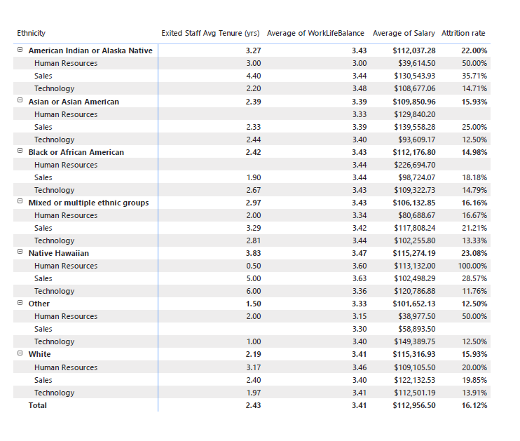

**Key Findings by Ethnicity:**

**1. American Indian or Alaska Native**

* **Attrition Rate:** 22% (Above average)
* **Tenure:** 3.27 years (Above average)
* **Salary:** $112,037.28 (Close to overall avg)
* **Work-Life Balance:** 3.43
* **Insights:** Despite a higher-than-average tenure, attrition is elevated, possibly signaling other underlying dissatisfaction factors. Sales department shows the highest attrition.

**2. Asian or Asian American**

* **Attrition Rate:** 15.93% (Slightly below average)
* **Tenure:** 2.39 years
* **Salary:** $109,850.96
* **Work-Life Balance:** 3.39
* **Insights:** Overall metrics are in line with company averages. Moderate attrition suggests balanced conditions, though lower tenure may be worth exploring.

**3. Black or African American**

* **Attrition Rate:** 14.98% (Below average)
* **Tenure:** 2.42 years
* **Salary:** $112,176.80
* **Work-Life Balance:** 3.43
* **Insights:** Stable performance and retention indicators. Sales department has a lower tenure (1.90 yrs), suggesting targeted issues there.

**4. Mixed or Multiple Ethnic Groups**

* **Attrition Rate:** 16.16% (Slightly above average)
* **Tenure:** 2.97 years
* **Salary:** $106,132.85
* **Work-Life Balance:** 3.43
* **Insights:** Longer average tenure indicates acceptable work conditions, but attrition still warrants department-level review.

**5. Native Hawaiian**

* **Attrition Rate:** 23.08% (Highest observed)
* **Tenure:** 3.83 years (Highest overall)
* **Salary:** $115,274.19
* **Work-Life Balance:** 3.47
* **Insights:** Despite high tenure and compensation, attrition is very high, especially in sales (28.57%). May suggest burnout or unaddressed cultural/workplace challenges.

**6. Other Ethnicities**

* **Attrition Rate:** 12.50% (Lowest)
* **Tenure:** 1.50 years (Lowest)
* **Salary:** $101,652.13
* **Work-Life Balance:** 3.33
* **Insights:** Short tenure and low attrition may indicate newer hires or smaller representation. Close monitoring recommended as more data becomes available.

**7. White**

* **Attrition Rate:** 15.93% (Matches company average)
* **Tenure:** 2.19 years
* **Salary:** $115,316.93
* **Work-Life Balance:** 3.41
* **Insights:** Metrics are closely aligned with organizational averages. Sales department shows slightly higher attrition.

**Departmental Observations:**

* **Sales Department** consistently reflects **higher attrition and lower tenures** across almost all ethnicities.
* **Technology Department** shows more stability, with **moderate attrition** and consistent work-life balance.
* **Human Resources** displays **lower headcounts** and greater variability across metrics, especially in ethnic minorities.

**Conclusion & Recommendations:**

The Attrition Analysis conducted for Palo Technology Limited over a ten-year period (2012-2022) reveal critical patterns, risk indicators, and actionable insights regarding employee turnover. With an overall attrition rate of 16.12% and a total of 237 exits out of 1,470 employees, the data underscores the need for a targeted and strategic approach to workforce retention. Attrition is not uniform across the organization—it is highly concentrated in the Technology and Sales departments, which together account for over 75% of total exits. Particularly concerning is the Technology department, where more than half of all attrition occurs, pointing to systemic issues potentially related to job pressure, compensation mismatch, or limited career progression. Similarly, Sales roles, especially Sales Representatives and Executives, show significantly higher turnover, likely linked to compensation dissatisfaction and workload imbalance.

Age-based analysis identifies that younger employees (particularly those aged 28–30) are the most at risk of attrition, with rates exceeding 47%. This signals a need to focus on early-career engagement, mentoring, and career development opportunities to retain younger talent. Moreover, education level appears to have a modest but notable impact—employees with lower educational qualifications experience slightly higher attrition, although it is distributed across all levels.

Gender-based insights show that while male employees represent the highest attrition rate (18%), female and non-binary staff also face notable turnover, especially within key roles such as Data Scientists, Software Engineers, and Sales Executives. Compensation disparities, uneven tenure, and skewed departmental representation point to possible underlying issues with gender equity and inclusivity.

Ethnicity-specific findings uncover that certain minority groups, particularly Native Hawaiian and American Indian or Alaska Native employees, show alarmingly high attrition rates (23.08% and 22%, respectively), even when tenure and compensation are above average. This indicates the presence of latent dissatisfaction, potentially tied to workplace culture, lack of representation, or unmet expectations. The Sales department emerges again as a primary area of concern across most ethnic groups, with lower tenures and higher exits.

Role-based analysis supports the hypothesis that salary, training opportunities, and career satisfaction are strong predictors of attrition. Employees in high-turnover roles often earn below the company-wide average salary ($60,000) and report limited access to training and development. Conversely, leadership roles with higher compensation and greater tenure show much lower attrition, reinforcing the need for balanced investment across all levels of the organization.

Work-life balance, though reported as neutral to moderately positive across the board, does not seem to offset dissatisfaction in high-pressure roles or departments with weak development pipelines.

**Final Recommendations**

The company should:

* 1. **revamp retention strategy** in the technology and sales department, focusing on workload management, career development paths and inclusion of bonuses.
  2. **Prioritize Early-Career Talent Development:** Implementing structured, early career trainings and fast track growth opportunities for employees under 30 and mentorship.
  3. **Conduct exit interview:** especially in departments and demographics in order to get comment response on their reason for leaving the company
  4. **Reevaluate Compensation models:** The data showed attrition rate for various roles who earned below the average of $60,000